**Determine pulley diameters:**

Steering shaft column outer diameter: 15mm  
Steering shaft column inner diameter: 10mm

Motor shaft diameter:

The motor shaft of the AK80-9 motor will be customized to suit the mounting on the motor hub. The diameter of the shaft will

**Belt Selection:**

(Belts comparison - Source: Childs, Peter R.N.. (2014). Mechanical Design Engineering Handbook. Elsevier)

There are several types of pulley belts available such as flat, V, Wedge, Synchronous belts along with other types.   
Referring to the Table 12.1, synchronous belts can output an optimum efficiency of up to 98%, due to their teeth engagement between the belt teeth and the grooves of the pulley. Due to the required precise motion control of an autonomous steering system, a slippage between the belt and the pulley is highly not preferred, which the synchronous belt as the name suggests provides exact shaft synchronization (with the exception of belt creep).  
Synchronous belts need significantly lower installation tension compared to V-belts, which results in reduced stress on drive components like shafts and bearings. Hence, along with the Figure 12.4, synchronous belt has been selected.

## General Selection Procedure – Synchronous belt pulley system

1. **Define the rotational speeds of the motor shafts.**

Rated motor (AK80-9) speed:

- 390 rpm at 9nm (rated torque)  
- ~305 rpm at 18nm (at peak torque)

Motor Analysis Chart

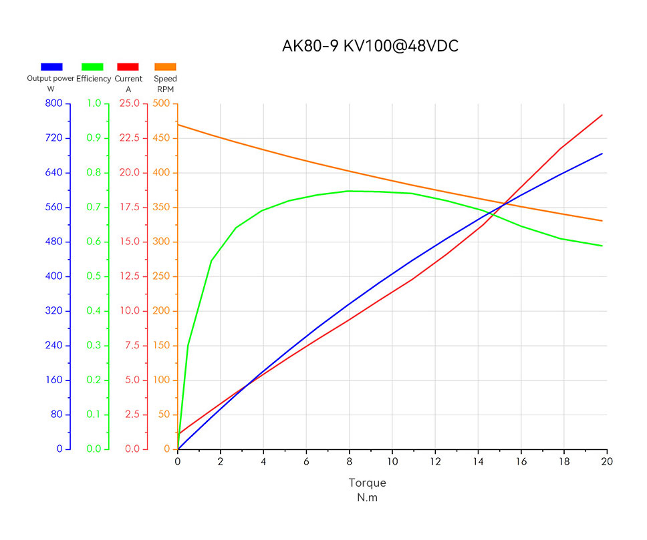

N.m to hp:

$$P(\text{HP})=\frac{T(\text{Nm})×N(\text{RPM})}{7127}$$

For 9nm:

$P(\text{HP})=\frac{9(\text{Nm})×390(\text{RPM})}{7127}$ = 0.49 HP

For 18nm:

$P(\text{HP})=\frac{18(\text{Nm})×305(\text{RPM})}{7127}$ = 0.77 HP

1. **Determine the service factor.**

Using Table 7-8 below, using good engineering judgement, a service factor of 1.2 has been selected.

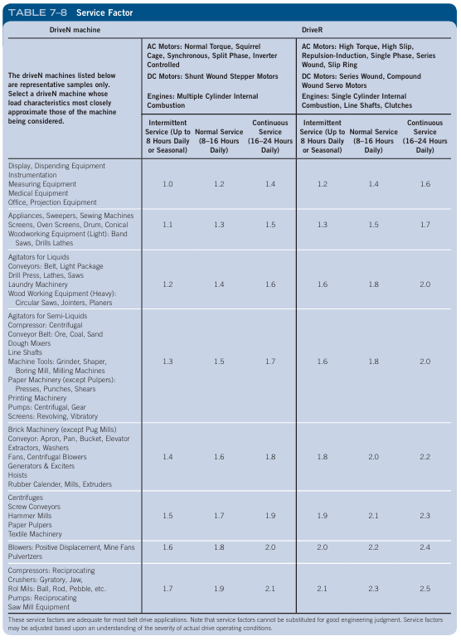

1. **Calculate the design power.**



Using the formula above;

- the design rated power is = 0.49 HP x 1.2 = 0.59 HP (0.59 x 0.7457 = 0.44 kW)  
- the design peak power is = 0.77 HP x 1.2 = 0.92 HP (0.92 x 0.7457 = 0.69kW)

1. **Determine required pitch of the belt.**

Figure 7–27 Belt pitch selection guide for GT style belts

Using the table above, the red lines depicts the selection for operational torque, whilst the blue lines indicate the use of peak torque. Since the majority of the imaginary curve from the red line intersection to the blue line intersection, a 5mm belt pitch would be considered a reasonable design choice. However, 8mm had to be chosen due to belt selection requirements.

1. **Determine the velocity ratio VR belt between the driver and driven sprockets.**

To determine the sizes/ratio of the driven and driver pulleys, giving the following:

Motor operational torque: 9nm  
Required torque: 24.9nm

An adequate pulley size ratio is needed to meet the steering force requirement of 24.9nm.

As the torque ratio is directly related to the velocity ratio:

Torque ratio = $\frac{Torque Required (Driven)}{Motor Torque (Driver)}$

Using the values of 9nm of motor torque, with 24.9nm of required torque:

**Torque ratio = $\frac{24.9 nm}{9nm}$ ≈ 2.76**

Therefore the driven pulley (on steering column shaft) must be 2.76 or more greater than the driver pulley (on the motor).

At peak torque during static or during sudden spikes:

Motor operational torque: 18nm  
Required torque: 24.9nm

**Torque ratio = $\frac{24.9 nm}{18nm}$ ≈ 1.38**

Thus, the driven pulley (attached to the steering column shaft) needs to be at least 1.38 times larger than the driver pulley (connected to the motor).

1. **Pulley selection**

**

**8mm Pitch Belt:**

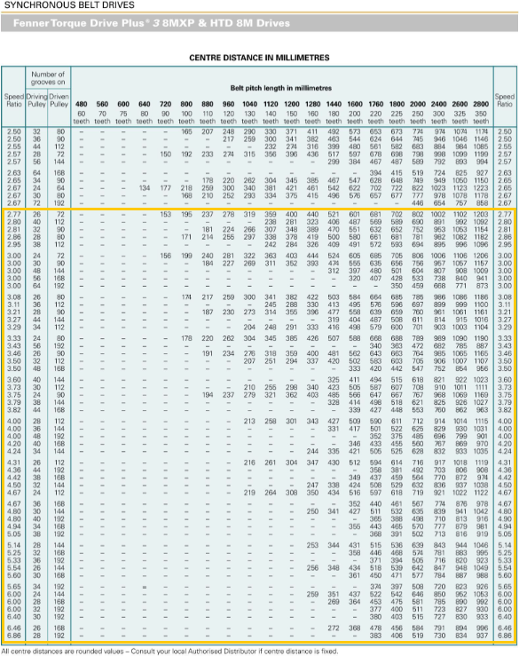

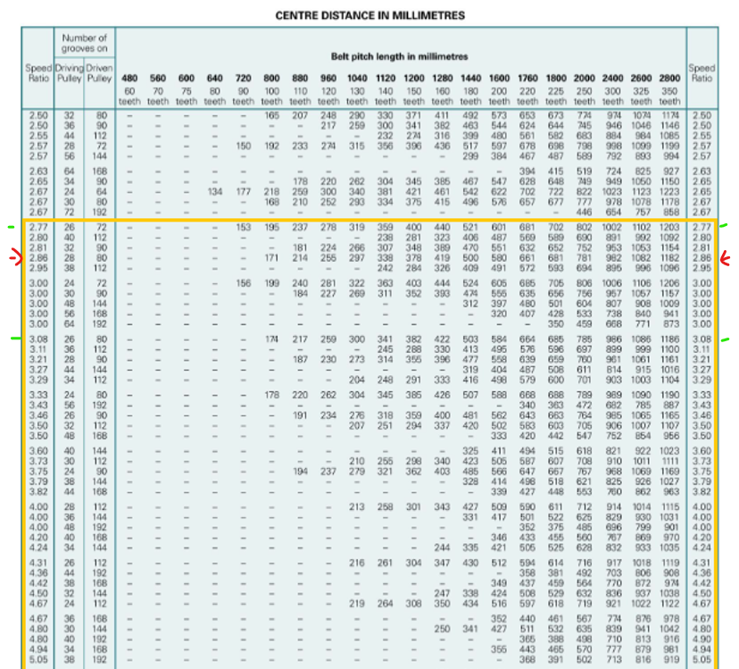

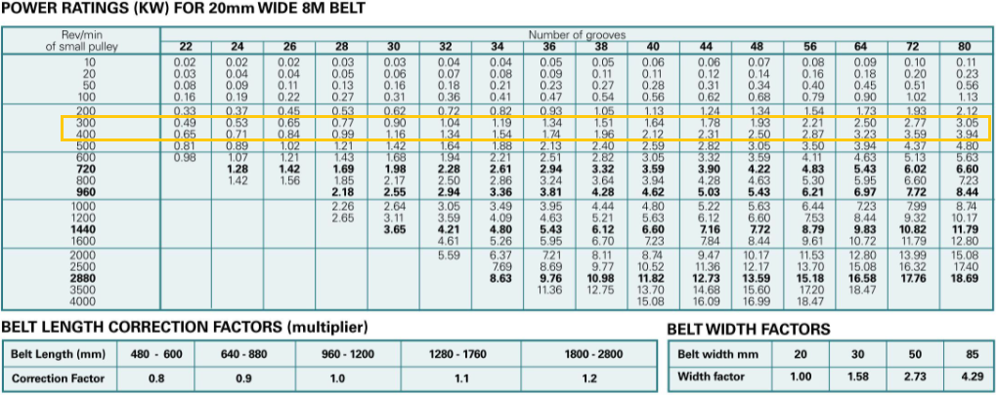

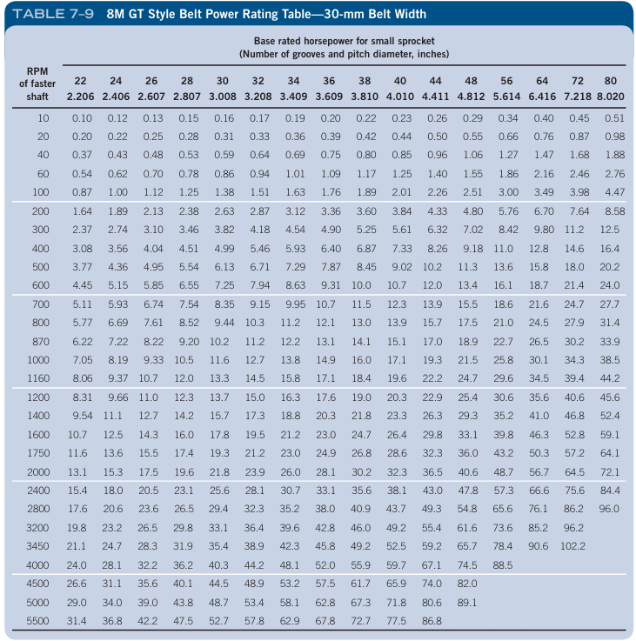

**Possible selections for 8mm pitch 20mm width belt:**

**2.86 SR - 28 - 80:**

Pulley flange (outer) diameter (motor): 28: 80.01mm

Pulley width (motor): 28.96mm

Pulley flange (outer) diameter (shaft column): 80: 213mm

Pulley width (shaft column): 44.45mm

**3.0 SR - 30 - 90:**

Pulley flange (outer) diameter: 30 (motor): 84.98mm

Pulley flange (outer) diameter: 90 (shaft column): 229.1842mm

**2.77 SR - 26 – 72:**

 Pulley flange (outer) diameter (motor): 26: 75.0062mm

Pulley flange (outer) diameter: 72 (shaft column): 192.99mm

**Possible selections for 8mm pitch 30mm width belt:**

Looking to reduce both pulley sizes, especially the flange (outer) diameter of the driven pulley, mainly due to space constraints, using belt width 1 size up from 20mm, that's the 30mm, to (there are 25mm out there, but can't find a chart for it). So, looking around the circled area around 200-400rpm range, for 0.92 HP at 18nm (previous 2 charts power figs are in kW), referring to the CD chart, 3.00 SR - 24 - 72 seems like to best choice, resulting in the driven pulley OD to about 190mm (I guess exact flange outer diameter depending on pulley brand).

**6b)**

**2.86 SR - 28 - 80:**28: 1108

Selected 20mm shaft OD: 20mm bore, 6mm keyway.

<https://www.ptparts.com.au/products/category/WLWAAFJG-1108/FG1108-M12--1108-taper-lock-bush-metric-bore-size>

80: 2517

Minimum is 16mm.

16mm shaft OD: 16mm bore, 5mm keyway.

https://www.aimsindustrial.com.au/2517-series-42mm-bore-12-x-8mm-key-taper-lock-bush?srsltid=AfmBOopofNy5FKcOtweQYt3nRbVyGHMUo6jJECptlSR3qn1qn1le1Zwp

https://www.ptparts.com.au/products/category/HNPEHAAK-2517/FG2517-M19--2517-taper-lock-bush-metric-bore-sizes

1. **Belt length, centre distance**

Centre Distance adjustability:

Need to make the baseplate to rail adjustable by at least 4.5mm, Driven pulley (7.598in) minus driver pulley (7.218in) divided by 2) that's just facing steering column side. to be able to fit belt on. To tighten belt, need a few mms facing front of car. So maybe I estimate 15mm ~total adjustment for the slotted holes.

Belt length:

From the specifications of a 3.00 SR – 24 (driver) – 72 (driven) setup, the belt length is 720mm.

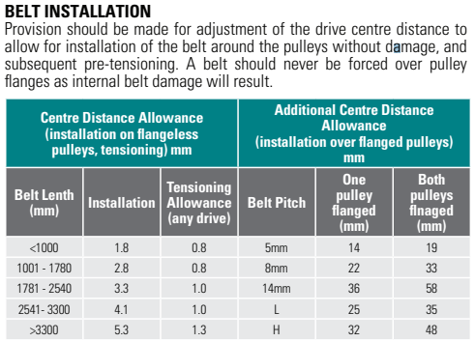

However, according to this chart, the allowance centre distance adjustment for our design, seems to be 33mm. I assume this is for adjustment on both sides from the driven pulley’s central axis, so about 16mm adjustment on both sides.

**Tensioning mechanism:**

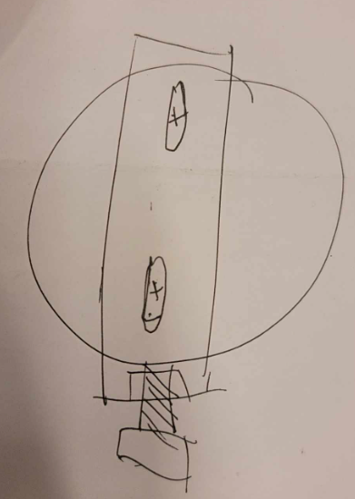

Shown above is the idea of the slotted holes and the bolt/grub screw tightening mechanism to be placed in pairs on the side facing the column shaft to be able to finely adjustable the belt tension.

Pictures of the ’23 UTSMA car (current):

Current motor and its motor would obviously not be in our design of the ’22 chassis, however, they could be used as a reference. The motor mount distance is approximately 15cm. So 15cm is about the distance between the legs we can work off with.

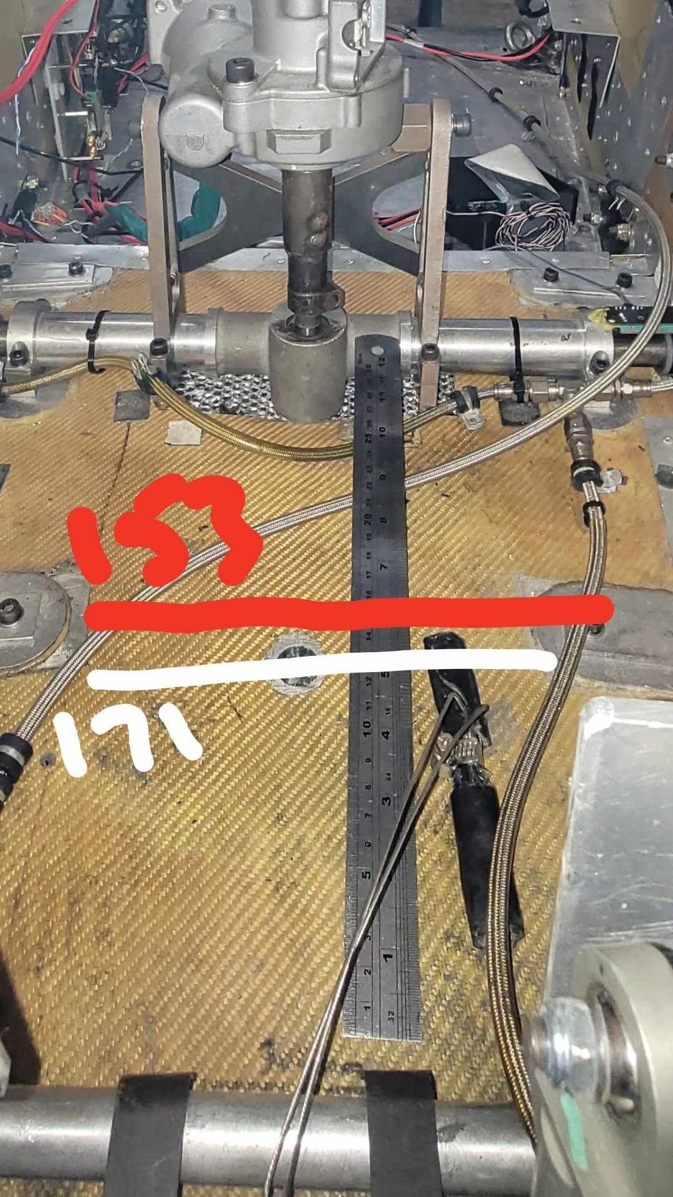

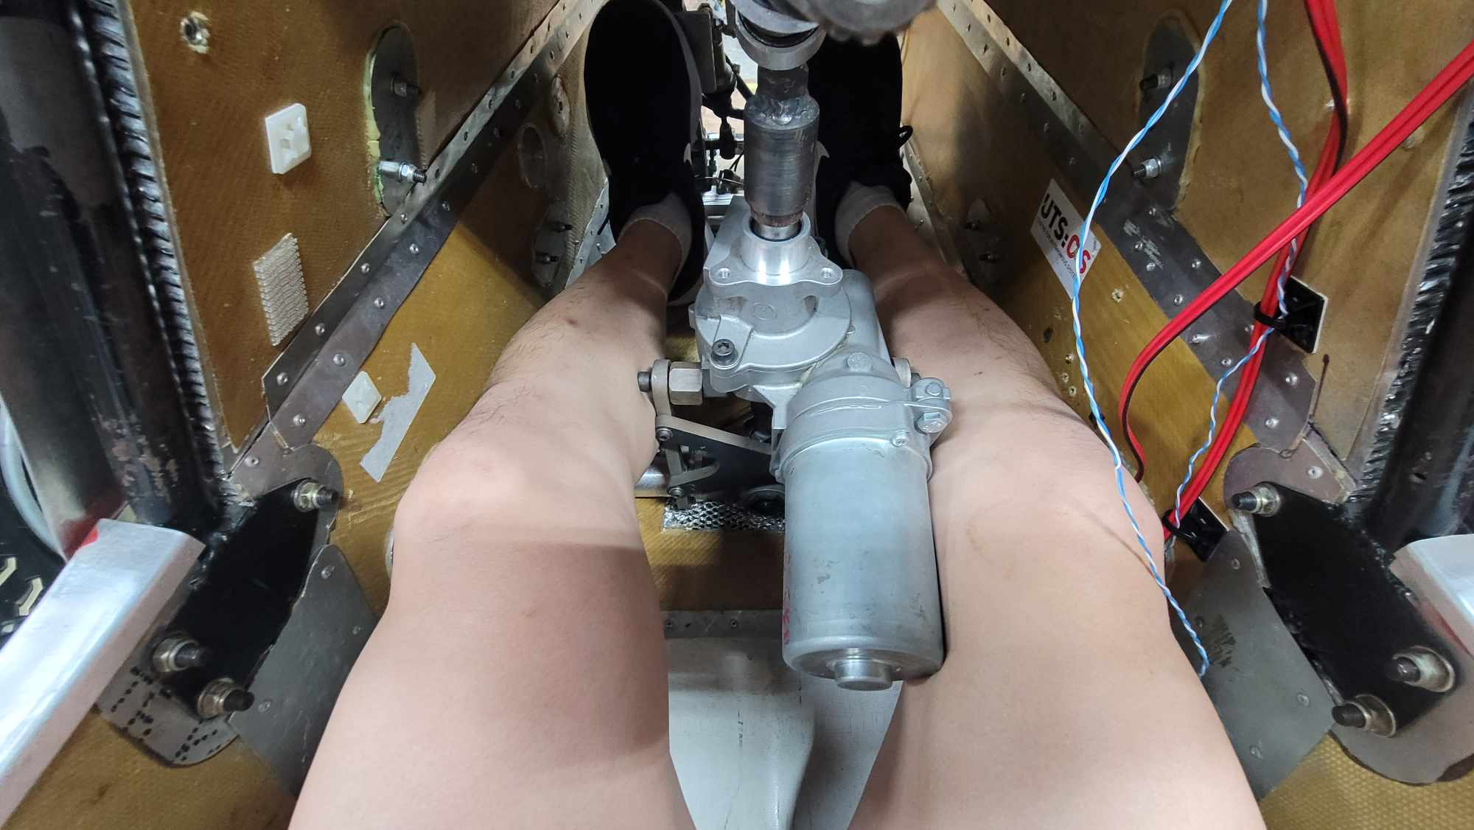

1. **Power Correction Factor**

The belt length correction factor adjusts the belt’s power rating when its length differs from the standard base length.

For 2.86 SR – 28 – 80, belt pitch length is 800mm, correction factor is 0.9.



At 300 rpm:

0.77 x 0.9 = 0.693 kW

At 400 rpm:

0.99 x0.9 = 0.891 kW

**10. Belt Width Factor**

The Belt Width Factor adjusts the belt’s power rating according to its width, reflecting the belt’s varying capacity to transmit power as its width changes.

Belt Width Factor = Design Power / Base Rated Power adjusted

300 rpm (Low torque and 18nm):

0.44 / 0.693 = 0.635

400 rpm (9nm):

0.69 / 0.891 = 0.774

Using the Belt Width Factor formula, reassures that a 20mm width belt is needed.

Belt Tension:

Pulley parts:

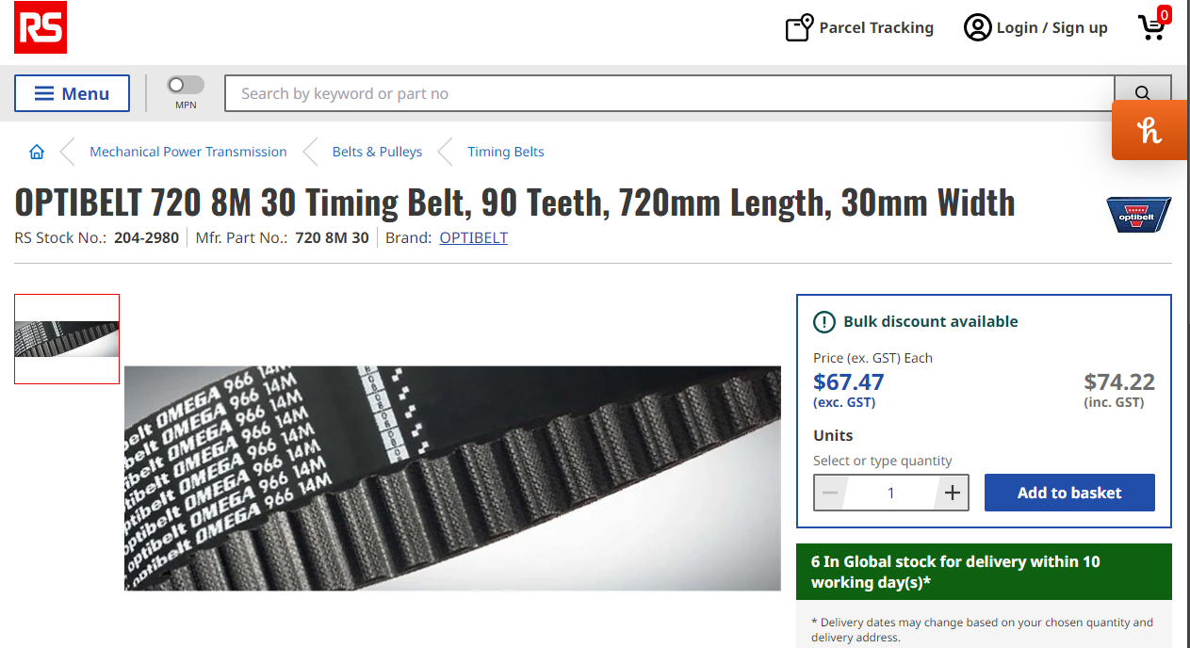

* <https://au.rs-online.com/web/p/timing-belts/2042980?srsltid=AfmBOooJuT_G5nIpk6O1Zk7FUJwPoUfnSPehmO_nd-GR0ldMPRDzgsEk>

<https://www.biedlers-belts.com/gates-p72-8mgt-20-sprocket.html>

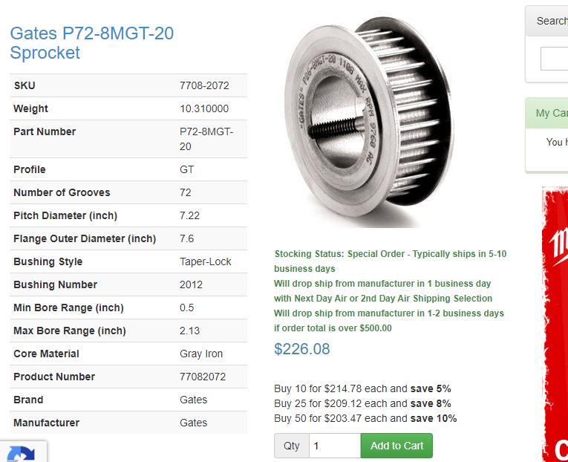

**https://www.biedlers-belts.com/gates-p72-8mgt-20-sprocket.html**

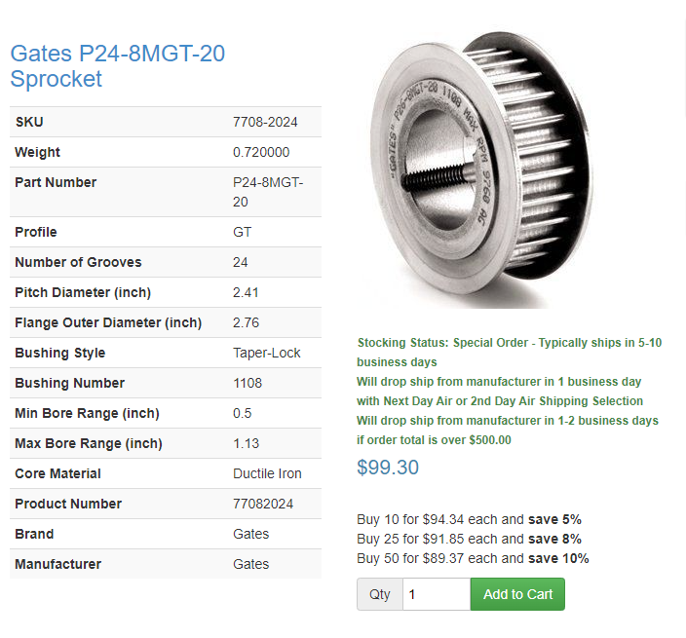

https://www.biedlers-belts.com/gates-p24-8mgt-20-sprocket.html

References:

https://www.linearmotiontips.com/synchronous-belt-v-belt-motion-design/  
<https://megadynegroup.com/en/blog/synchronous-belts-vs-v-belts>

<https://store.tmotor.com/product/ak80-9-dynamical-modular.html>  
<https://www.yumpu.com/en/document/read/37895648/fenner-torque-drive-plusr-3-and-htd-drives>  
https://www.fpt.com.sg/server/Public/1%20Fenner%20Power%20Transmission%20Resources/3%20Fenner%20Installation%20Guides/Installation_Guide_-_Synchronous_Drives.pdf?view=1